***Sales Bar Chart*** – Write a program that asks the user to enter today’s sales for each of three stores. The program should then produce a bar graph displaying each store’s sales. Create each bar in the graphs by displaying a row of asterisks. Each asterisk should represent $100 of sales rounded to the nearest $100.

**NOTE:** You may want to use the *round* function found in the math library. You will need to include math.h and declare your sales variables as floats.

**Validation:** Validate that each sales figure entered is >= 0 using a validation loop.

**Sample Dialog:**

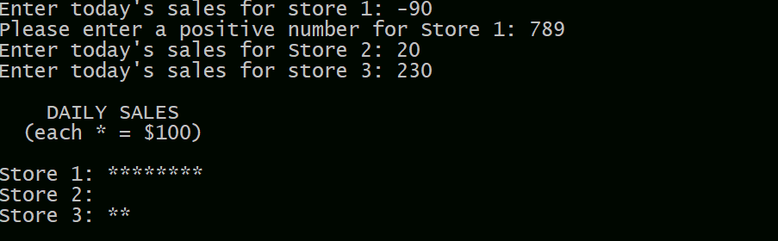

**Other Requirements**

See Programming Style Requirements. You should have 1 program file to turn in with the naming convention yourlastname_Ch5lab.cpp.